PrISM: Programming Interface for Sensors and Motors

Sarala Verma, Rituraj Singh, and Amitabha Mukerjee,

Indian Institute of Technology, Kanpur, India
amit@iitk.ac.in, saralav@iitk.ac.in, rituraj@iitk.ac.in

I hear and I forget, I see and I remember, I do and I understand
- Ancient Chinese proverb

Design Overview

Unlike text book learning, programming provides a mechanism for immediately testing and verifying one's ideas. In the west, the ubiquity of computers provides learners with an interactive mode for testing and developing learning objectives.

In India however, computers are accessible only to a few elite urban schools: even when a rural school has a computer, students get only one hour a week, and often share the keyboard at that. Also, electricity may be erratic, or the software / system may be obsolete.

In this paper we present a Build Robots Create Science (BRiCS) initiative, which emphasizes interactivity by developing low-cost devices that can be programmed without computers. The device can interact with simple sensors and motion systems that the child himself can build. In widespread tests conducted at schools across India, we also find the children responsive to the emotionally appealing topic of Robotics. In particular, this paper focuses on two digital learning tools, which have been developed as part of BRiCS:

1. PrISM (Programmable Interface for Sensors and Motors): programming is done through a set of functionally defined keys, on a small handheld keyboard.
2. Programmable Blocks: a physical programming tool. Can be used for programming electronic equipments. It consists of physical blocks, each representing a particular command and a flowchart of the program is implemented by stacking of these blocks.

These and similar tools are deployed by involving the children in a small group along with a mentor, whose chief function is to encourage the child to take ownership of her own idea. Typical workshops consist of 20-30 children, and 5-6 mentors. Children from rural or underprivileged backgrounds exhibit more creativity and less gender bias than those from wealthier settings. In a number of tests across India, the response from students, as well as a significant proportion of educators, has been overwhelming, and voluntary BRiCS chapters are opening in colleges to conduct regular interaction sessions at schools on a widespread basis.

1. Motivation

In the developed nations, “digital” learning tools, and in particular the computer, serves to introduce the child to the notions of systematic problem solving and logical thinking via programming and other interactions. In India however, especially the rural schools, computers remain unaffordable due to high costs. Even where a computer is available, the resources needed to utilise it, such as, stable electricity, up-to-date software, trained manpower, etc are unavailable. At the same time, it is possible to reap many of the benefits of digital learning such as logical thinking without using the computer – indeed, if accompanied by tasks such as building their own interactive toys, it can be more pleasurable than computer simulations. Thus, there is a dire need for developing interactive programmable devices that are low cost and are easy to learn and use.
The Build Robots Create Science (BRiCS) project is trying to contribute in this regard by developing some low cost programmable devices. In widespread tests conducted at schools across India, we find children more responsive to the emotionally appealing topic of Robotics, and these low cost tools primarily aim at programming simple interactive devices which enable the child to learn the concepts of logical thinking and programming.

BRiCS is an activity that started at IIT Kanpur in 2001 and has two aspects – development of low cost tools for hands-on education, and development of a process / pedagogy for facilitating the learning experience and making it a part of the normal educational process. In this paper, we outline two of the programmable interfaces that are being developed -- the PrISM (Programmable Interface for Sensors and Motors) and the Programmable Blocks.

1.1 Programming for General Toys

Keyboard programming is widely used in a number of contexts such as programmable cars, calculators, or robots. These devices differ in aspects such as support for subroutines, branching, recursion etc. Mobile devices such as articulated robots provide functionality for remembering positions in the workspace (“teach” mode) which are then used as landmarks during its motion. A robot arm such as the PUMA560[Uni60] provides for a number of keys that permit the user to move each joint separately, or to move and rotate along a 3D line, and then to store these motions or to execute them directly. They also offer complex sensor-based branching for handling unexpected situations. However, most modern interfaces provide for direct programming in a nearly-recognizable programming language and do not rely much on the teach pendant. The simpler mobile robots, such as the Valiant Roamer[Valient] have about 20 keys (including ten digit keys) and an interface with the capability to store upto 99 subroutines. Some of the simpler robots aimed at primary school level do not provide for sensory branching.

In general however, most programmable interfaces for mobile devices are designed for the operation of a fixed hardware platform. In our application the specific hardware is not known a priori, since the child may be using it to control an unlimited variety of devices, limited only by the number of motors and sensors that can be controlled by this device.
As an example, consider that the child has made a toy car, and would like to have it move forward until it hits a wall. Then it should reverse for 1 sec, turn left, and continue. Similarly, let us say that the child has built a crane with one motor for the winch and another for the azimuth rotation, and wishes to program it so that the crane will lift up an object from (θ₁), lift it to a given height and deposit it at (θ₂). The challenge for our design is to come up with a keyboard layout or a set of programmable blocks that can program either of these configurations.

The next section describes a keyboard solution for this purpose, where the child can program these devices using a keyboard. The design seeks to minimize the number of keys and also the number of keystrokes needed to program a given task.

2. PrISM (Programmable Interface for Sensors and Motors)[Muk03]:

This device accepts a user program through the keyboard, displays it on the LCD, and stores it in the memory. PRiSM can control upto two motors and handle inputs from upto three sensors. When the run command is given, this program is executed and the corresponding operation is performed on the connected motors, considering the input from the Sensors at that time. Fig 1 shows the block diagram.

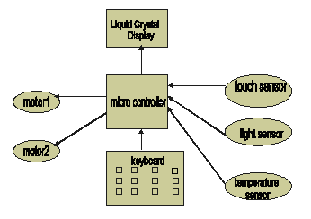
Figure1. Functional Overview of PrISM

This programmable tool has:
- 16 keys Keyboard unit for Input
- Microcontroller unit with internal memory for storage and control
- 16x4 Dot Matrix Liquid Crystal unit for display
- Motor controller for Output
- 9v Battery for power
- Sensor interfaces

The presence of the LCD permits us to provide a simpler interface since the user can see the effect of pressing certain keys – for example repeatedly pressing one key may scroll through a simple set of choices.

2.1 Sensor Interfaces

The sensor ports which can be connected to the system return an analog signal which is threshold at a fixed point by the PRiSM and accordingly the sensor is assumed to have returned True or False. The analog value sent by certain sensors (e.g. Light sensor) can be adjusted by a knob on the sensor itself. Other sensors such as the Touch Sensor or the Clap sensors return a high signal and are effectively digital. These sensors can also be made by the users themselves following directions. Each sensor is connected using 2 input lines on the input port of the Microcontroller. We also encourage the students to build their own sensors during the workshop using basic electronic components. The Touch sensor is built using a micro switch and resistors and enclosed in a plastic case as shown in figure 2a, with a Bill of Materials cost of about Rs. 10. The Light sensor uses Light Dependent Resistors (LDR) and some Resistors, also with the Bill of materials around Rs. 20. This is enclosed in a plastic case as shown in Figure 2b. A clap sensor has also been designed using a microphone and op amps but this is too complex to be made by school children.

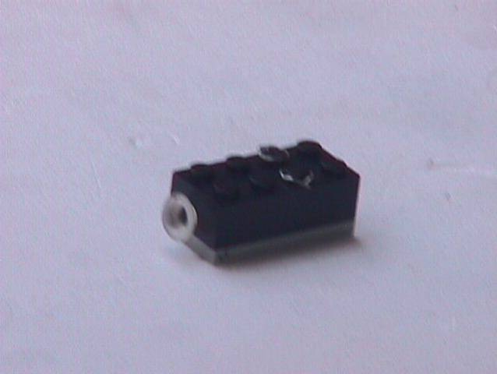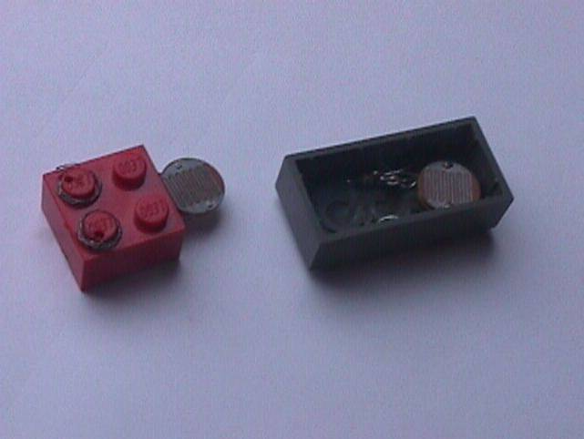
Figure 2a and 2b: Touch Sensor and Light Sensor built into LEGO blocks

2.2 Keyboard Design

The keyboard interface is aimed at children above the age of 12. It provides a 4x4 matrix layout with 16 keys where each key defines a particular programming function or a function of the motor. The key PROGRAM starts remembering keystrokes, and is pressed again to stop program memory. Stored programs can be run by pressing the RUN key, which also can be pressed to abort the program. The specific motor combination (only A, only B, A B same direction, A B opposite direction) can be selected by pressing “Select Motor” key repeatedly. Similarly, pressing the IF/WHILE/FOR key repeatedly selects the appropriate control instruction. The interfaces for the FOR, IF, WHILE are as follows:

FOR <NUM> (. . .)
IF [NOT] SENSOR (. . .) (. . .)
WHILE [NOT] SENSOR (. . .)

PROG
START/
STOP
ERASE/
NO
RUN/
ABORT/
YES
MOTOR
SELECT
WAIT/
REVERSE
IF/WHILE/
FOR
NOT
CURSOR
CURSOR
DECREMENT
INCREMENT
SENSOR
SELECT

Figure 3. PrISM keyboard layout

Note:

The different commands on the keyboard separated by a slash ‘/’ indicate that they work as different keys at different times
Wait is indicated on the LCD by ‘XX’
Reverse is indicated by ‘ <> ‘
Sensors can have values S1,S2,S3
‘No ‘ is to select yes/no for some queries like delete prog?,etc
‘Not’ is to negate the sensor value
‘Decrement/incre’ refer to the timer setting
‘Erase’ is to erase a particular command

2.3 Implementation

This is based on an 8051 family Microcontroller which has RAM for data storage and Flash RAM for program storage. It has four I/O ports, each connected to Keyboard, LCD, Sensors and Motor controller. This function in two modes: Program mode, during which it accepts the instructions from the keyboard and the Run mode, where the program is executed.

2.4 Display

Comprises of a 16X4 Liquid Crystal Display, where each line displays one key function along with its related parameters. The display scrolls up for more than four inputs. In the Run mode, this displays the lines currently under execution.

2.5 Motor Controller

This uses a motor controller IC L298.This has an internal H-Bridge which can control 2 motors. Each motor is controlled using one Enable and two data lines.
2.6 Power Supply

This system runs on a small 9v battery. A regulator IC7805 gives the 5v required for the microcontroller and the motors will run on 9v.

2.7 Applications of the PrISM:

- Can be used to control two Motors of any given mobile platform considering the input from the Sensors.
- Can be used to build toys from commonly available motors and program them.
- This can be used as an alternative teaching aid for hands-on experience in programming basics where the computer is not accessible.
- If the keyboard and the corresponding display messages are changed to symbols to indicate the particular action, the language barrier and also the knowledge of English language as a prerequisite for learning Programming, can be overcome.

2.8 Sample Keystrokes:

Sample keystrokes for the toy car

PROG_START
WHILE NOT SENSOR (MOTOR_AB 5) ;num 5 is i/p using INCREMENT key

(MOTOR_A 1 MOTOR_AB REVERSE 5) ;1 and 5 are time in secs
PROG_END

RUN

Sample keystrokes – Program for crane

PROG_START
MOTOR_A 3 ; Move the Motor A 3 secs to hold the Object

MOTOR_B 5 ; Move the Motor B 3 secs to shift the Object

MOTOR_A 3 ; Move the Motor A in opposite direction to Place
the object
PROG_END

RUN

2.9 Cost factor

The total cost of the PrISM would be approximately INR 3000. Variations can be made on the type of display and the keyboard to suit various needs, as these are the main factors that decide the cost.

